Lesson plan 1
Form: 3
Topic: Food and drinks. Likes ans dislikes
Aims of the lesson:
By the end of the lesson pupils will be able to:
-ask and answer the questions about own preferences in food
-tell about someone’s likes and dislikes in food and drinks
-read and guess riddles about food
-complete simple sentences
Type of the lesson: Learning new vocabulary

Stage | Time | Description | Stage aim
I. Organising the Class. Greeting | 2’ | T. Good morning pupils, I’m glad to see you, tell me, please, what do you like to eat for breakfast?  (Ex. I like eggs or I like sandwiches or I like cereal) | to welcome pupils
2) Introducing the Topic | 2’ | Our topic is “Food and drinks” and after few lessons we will know more about food and drinks and we will make a project about it | to introduce the topic
II. Warming up: mime game | 6’ | T. you need to answer the question “What do you eat for dinner?” without words,only moves  (Each pupil shows his dinner with actions, the others need to guess what was that) | to make pupils interested
III. Presenting Vocabulary:  Chant | 2’  3’ | -Work with flash-cards. Teacher shows,say, pupils repeat  -Chant. Teacher says,pupils repeat  salad  salad and bread  salad, bread and pasta  salad, bread, pasta and soup  salad, bread, pasta, soup and fish  salad, bread, pasta, soup, fish, chicken and fries  salad, bread, pasta, soup, fish, chicken, corn and fries  soda and milk  soda, milk and juice  soda, milk, juice and water | to present new words  to have practice in speaking and listening of new words
IV. Practising Vocabulary: The game  “What’s missing?” | 2’ | T. Now you need to match the picture with right card (HO1) (each pupil do that on his own) | To revise pupils understanding of vocabulary
V. Relaxation: | 3’ | T. Well, I think it’s time to have a pause, so let’s move a little.  Bread and butter, milk and tea,  Put your finger on your knee.  Bread and butter, cake and ice,  Put your hands on your eyes.  Bread and butter, duck and rose,  Put your finger on your nose.  Bread and butter, juice and eggs  Put your hands on your legs. | to make pupils relaxed
VI. Vocabulary Drill:  Pair work  Reading game-guessing riddles  Writing task | 5’  5’  5’  5’ | T.Please,divide into pairs. Ask questions to your friend and fill the table (HO2)  (Ex.Do you like fish? –Yes,I do.  Do you like fries? –No,I don’t)  T. Choose few facts about your friend and tell us  (Ex.Masha likes salad. She hates corn. She loves soda and don’t mind at fries)  T. Try to guess what’s this (HO3)  Vegetables and sometimes fruit mixed together salad\pasta\soup  Mum gives it to us every day soup\fish\corn  Little slices of potato fries\corn\soup  Long lines with tomato sause pasta\soup\fries  Cows are giving it milk\soda\water  It’s got bubbles soda\juice\milk  People can’t live without it water\milk\juice  T. Write the sentences in right order  (HO4) | to allow the pupils to use new vocabulary in real life  To practice writing
VII. Home Assignment: | 1’ | T.Home task is to make a crossword about food. For example,choose one big word and build all crossword around it
VIII. Summing-up: | 4’ | T.Our lesson is almost over. Did you enjoy it? What new things have you learned today? And we had a really nice competition today. And let’s have marks

Handout 1
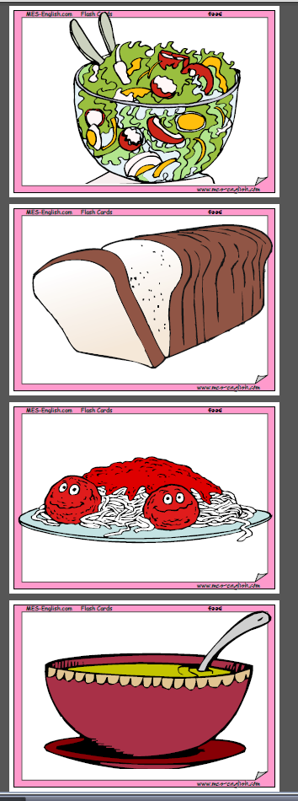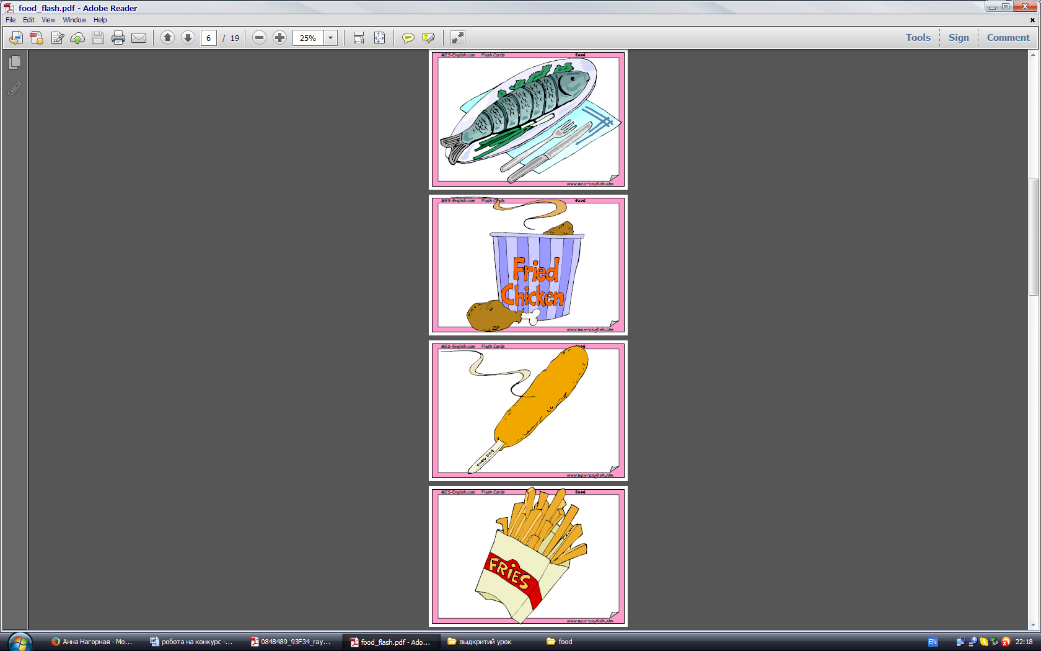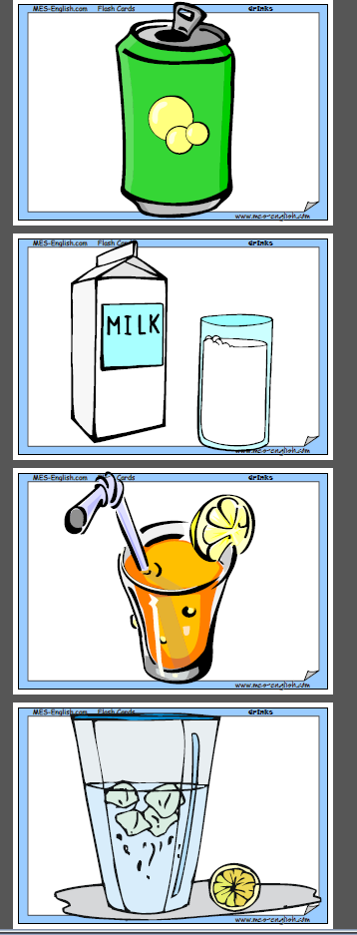

Salad | Corn
Bread | Fries
Pasta | Soda
Soup | Milk
Fish | Juice
Chicken | Water

Handout 2
Food  Name | Love |  | Like |  | Don’t mind |  | Hate

Food  Name | Love |  | Like |  | Don’t mind |  | Hate

Food  Name | Love |  | Like |  | Don’t mind |  | Hate

Handout 3
Vegetables and sometimes fruit mixed together salad\pasta\soup
Mum gives it to us every day soup\fish\corn
Little slices of potato fries\corn\soup
Long lines with tomato sauce pasta\soup\fries
Cows are giving it milk\soda\water
It’s got bubbles soda\juice\milk
People can’t live without it water\milk\juice

Vegetables and sometimes fruit mixed together salad\pasta\soup
Mum gives it to us every day soup\fish\corn
Little slices of potato fries\corn\soup
Long lines with tomato sauce pasta\soup\fries
Cows are giving it milk\soda\water
It’s got bubbles soda\juice\milk
People can’t live without it water\milk\juice

Vegetables and sometimes fruit mixed together salad\pasta\soup
Mum gives it to us every day soup\fish\corn
Little slices of potato fries\corn\soup
Long lines with tomato sauce pasta\soup\fries
Cows are giving it milk\soda\water
It’s got bubbles soda\juice\milk
People can’t live without it water\milk\juice

Vegetables and sometimes fruit mixed together salad\pasta\soup
Mum gives it to us every day soup\fish\corn
Little slices of potato fries\corn\soup
Long lines with tomato sauce pasta\soup\fries
Cows are giving it milk\soda\water
It’s got bubbles soda\juice\milk
People can’t live without it water\milk\juice

Vegetables and sometimes fruit mixed together salad\pasta\soup
Mum gives it to us every day soup\fish\corn
Little slices of potato fries\corn\soup
Long lines with tomato sauce pasta\soup\fries
Cows are giving it milk\soda\water
It’s got bubbles soda\juice\milk
People can’t live without it water\milk\juice
Handout 4
Kate\pasta\like\doesn’t_____________________________________
Unhealthy\soda\is\drink____________________________________
Orange\I\like\juice_________________________________________
Mum\bread\soup\and\gives\for lunch_______________________
Fruit\my\salad\is\favourite_________________________________
I\like\fish\don’t____________________________________________

Kate\pasta\like\doesn’t_____________________________________
Unhealthy\soda\is\drink____________________________________
Orange\I\like\juice_________________________________________
Mum\bread\soup\and\gives\for lunch_______________________
Fruit\my\salad\is\favourite_________________________________
I\like\fish\don’t____________________________________________

Kate\pasta\like\doesn’t_____________________________________
Unhealthy\soda\is\drink____________________________________
Orange\I\like\juice_________________________________________
Mum\bread\soup\and\gives\for lunch_______________________
Fruit\my\salad\is\favourite_________________________________
I\like\fish\don’t____________________________________________

Kate\pasta\like\doesn’t_____________________________________
Unhealthy\soda\is\drink____________________________________
Orange\I\like\juice_________________________________________
Mum\bread\soup\and\gives\for lunch_______________________
Fruit\my\salad\is\favourite_________________________________
I\like\fish\don’t____________________________________________

Kate\pasta\like\doesn’t_____________________________________
Unhealthy\soda\is\drink____________________________________
Orange\I\like\juice_________________________________________
Mum\bread\soup\and\gives\for lunch_______________________
Fruit\my\salad\is\favourite_________________________________
I\like\fish\don’t____________________________________________

